EXP NO 15: Create a Cloning of a VM and Test it by loading the Previous Version/Cloned VM

AIM:
To create a clone of an existing virtual machine using VMware Workstation (Type-2 Hypervisor) and verify its functionality by booting and testing the cloned virtual machine independently.
- RAM: 1 GB
- Hard Disk: 15 GB
- Processors: 2

PROCEDURE:
- Open VMware Workstation.
- Select the source virtual machine.
- Click VM → Manage → Clone.
- Select Create a Full Clone (or Linked Clone if instructed).
- Enter the clone name and storage location.
- Click Finish to create the cloned virtual machine.
- After cloning, select the cloned VM from the VMware Library.
- Click Power on this virtual machine.
- Verify that the cloned VM boots successfully and works independently of the original VM.

1.SELECTING MEMORY DATA(GB):

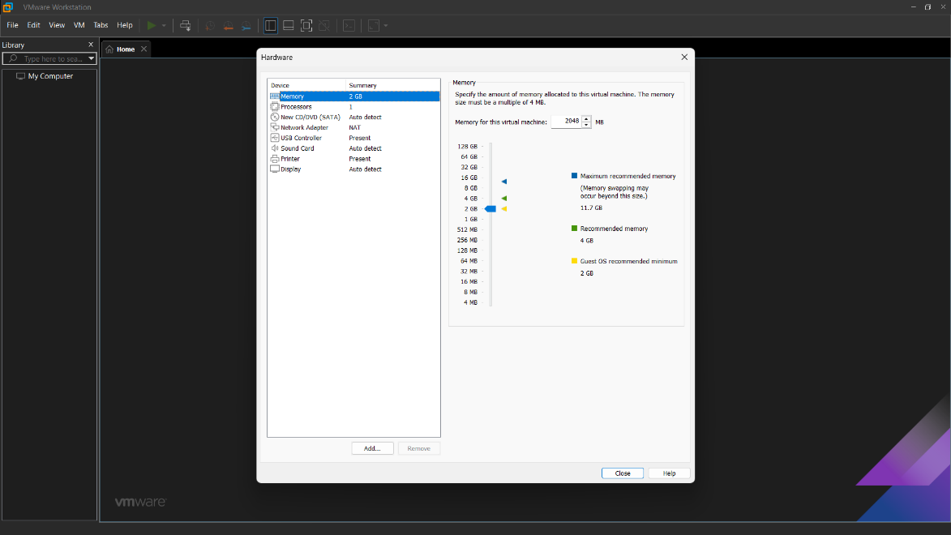

2.SELECTING NO. OF PROCESSORS:

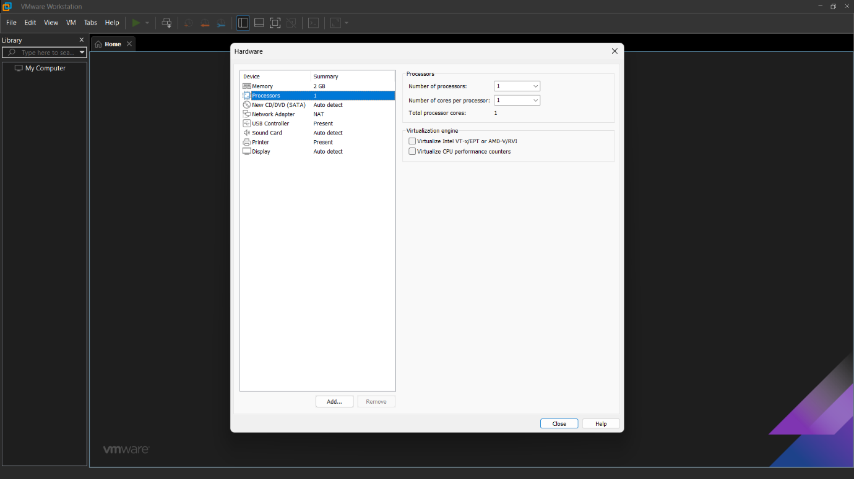

3.SETTING OF HARD DISK DATA(GB):

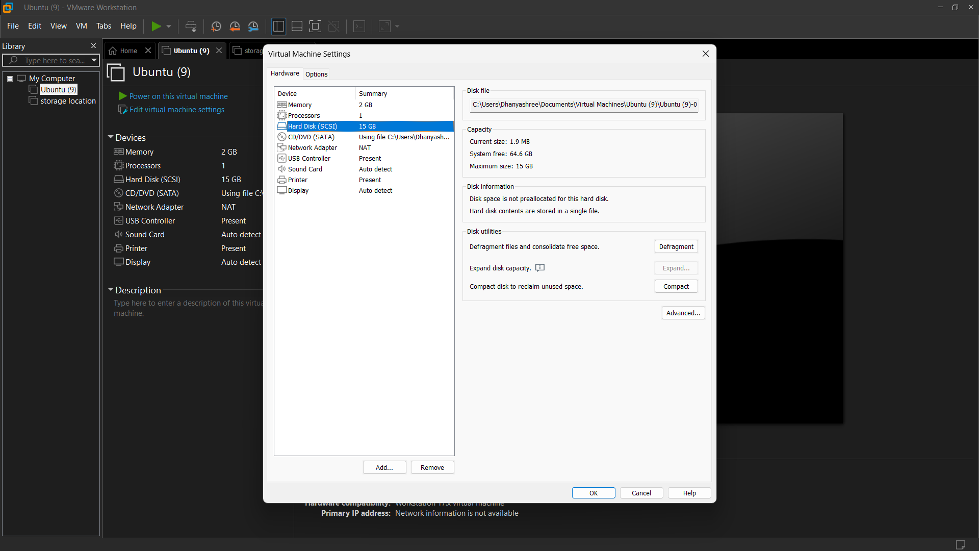

3. UPLOADING THE UBUNTU:
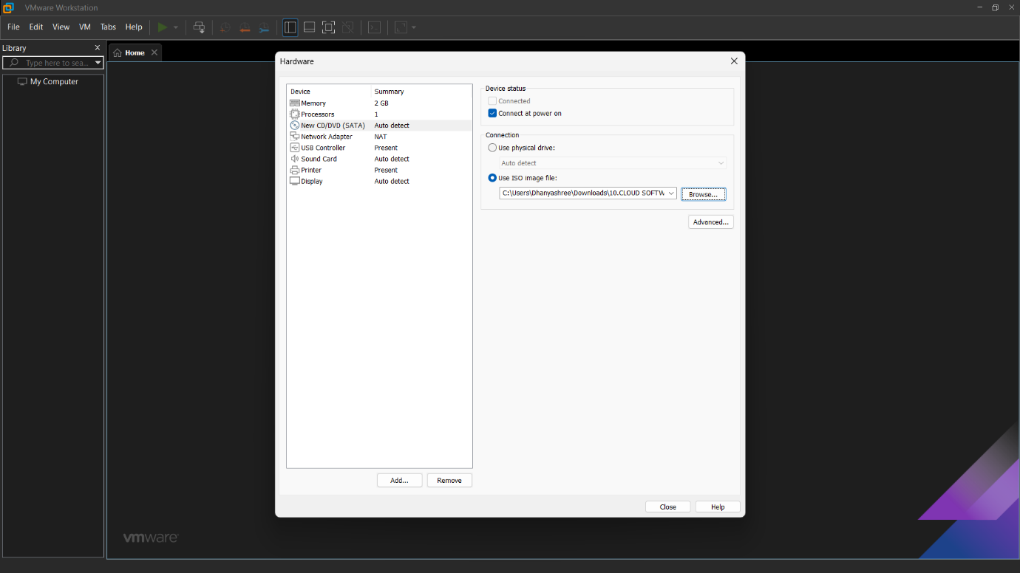

ADDING THE CLONE:
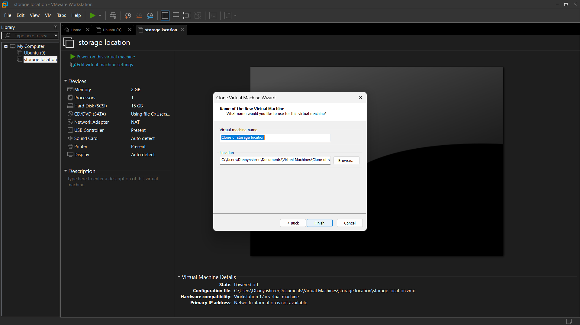
OUTPUT:
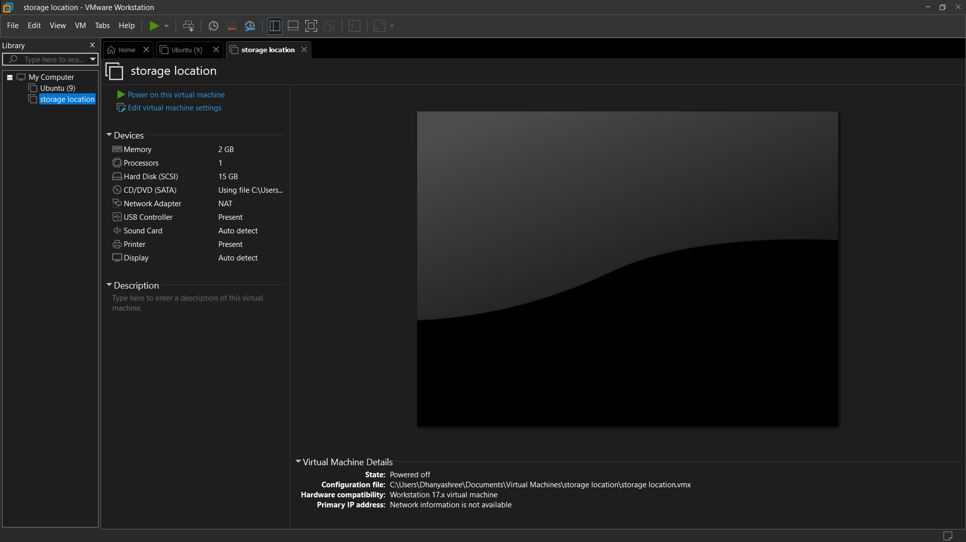
RESULT:
The virtual machine was successfully cloned and tested. The cloned virtual machine booted successfully and operated independently, confirming that the cloning process was completed successfully.

